Decision Tree Classification
Aim
To implement a Decision Tree classification algorithm in Python and classify the Iris dataset.
Objective
- To understand the working of a Decision Tree.
- To construct a classification model.
- To train the model using training data.
- To evaluate the model using accuracy.
Algorithm
- Load the Iris dataset.
- Separate the input features and target classes.
- Divide the dataset into training and testing sets.
- Create a Decision Tree classifier using the Gini Index.
- Train the classifier using the training data.
- Predict the classes of the test data.
- Compare predicted and actual classes.
- Calculate and display the classification accuracy.
FLOW CHART:
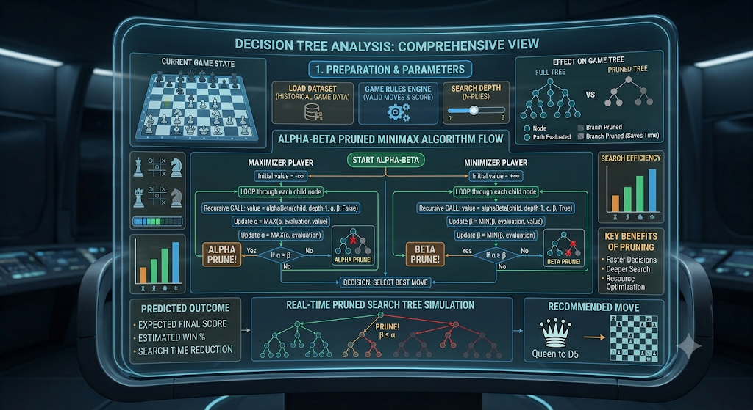
Python Code
from sklearn.datasets import load_iris
from sklearn.model_selection import train_test_split
from sklearn.tree import DecisionTreeClassifier
from sklearn.metrics import accuracy_score

# Load Iris dataset
iris = load_iris()

X = iris.data
y = iris.target

# Split dataset
X_train, X_test, y_train, y_test = train_test_split(
X, y,
test_size=0.2,
random_state=42
)

# Create Decision Tree
model = DecisionTreeClassifier(
criterion="gini",
random_state=42
)

# Train the model
model.fit(X_train, y_train)

# Predict test data
y_pred = model.predict(X_test)

# Calculate accuracy
accuracy = accuracy_score(y_test, y_pred)

print("Decision Tree Classification")
print("Accuracy:", accuracy)

OUTPUT:
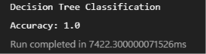
Result
Sample Output:
Decision Tree Classification
Accuracy: 1.0

